**Data Factory – Data Flows**

From the Author page, click ‘New data flow’:

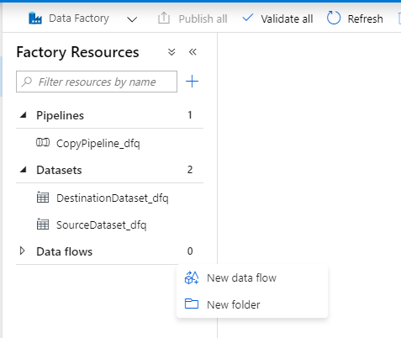

Select Mapping Data Flow:

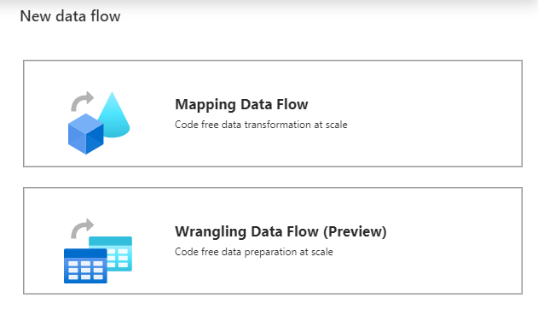

Configure the source settings in the configuration panel at the bottom:

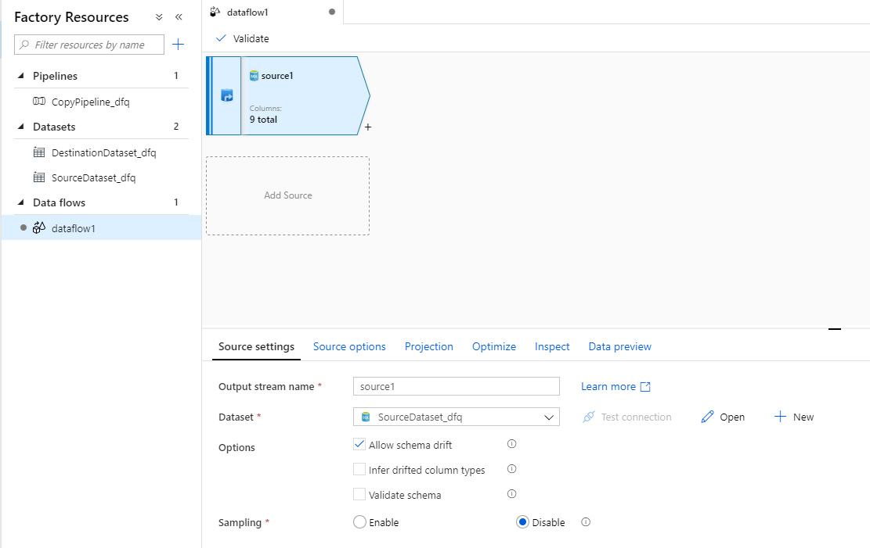

For this example, we want to add another column, so choose the ‘Derived Column’ transformation:

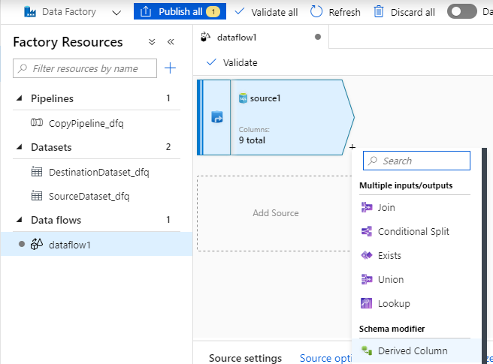

Configure the derived column settings:

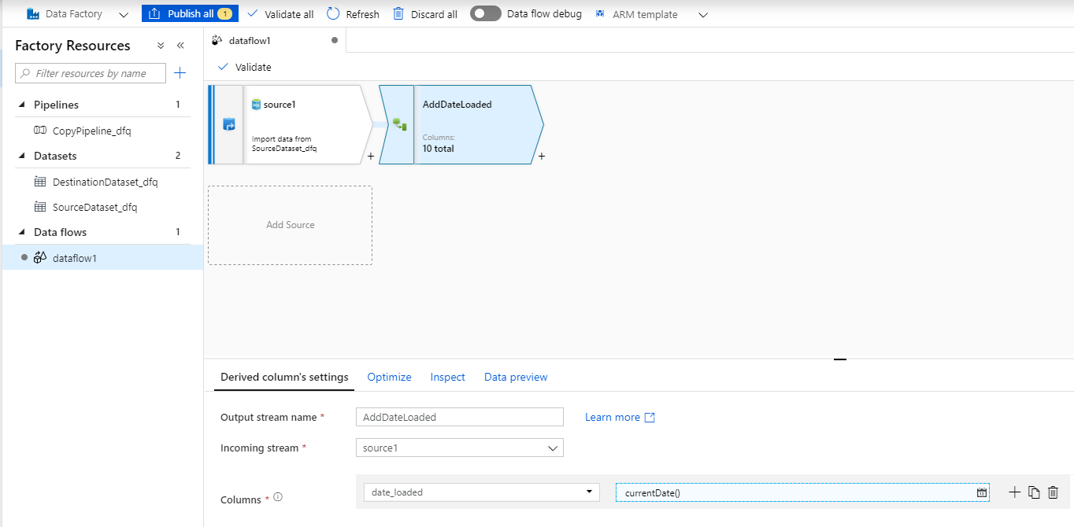

Configure the expression to populate the derived data column:

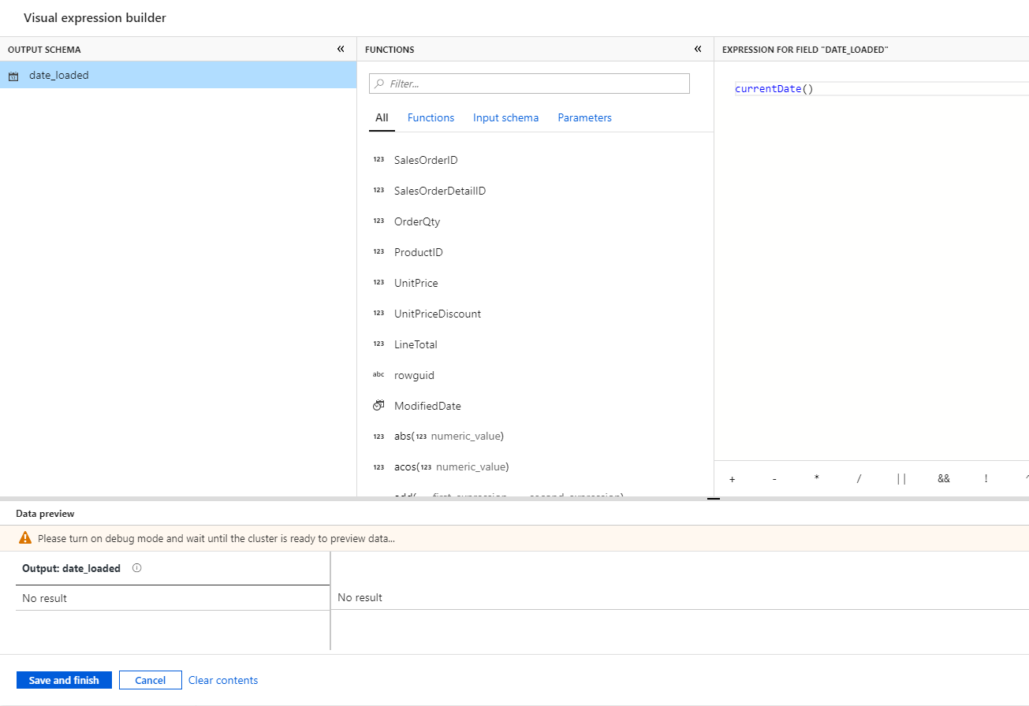

Now configure the sink for the data to go to:

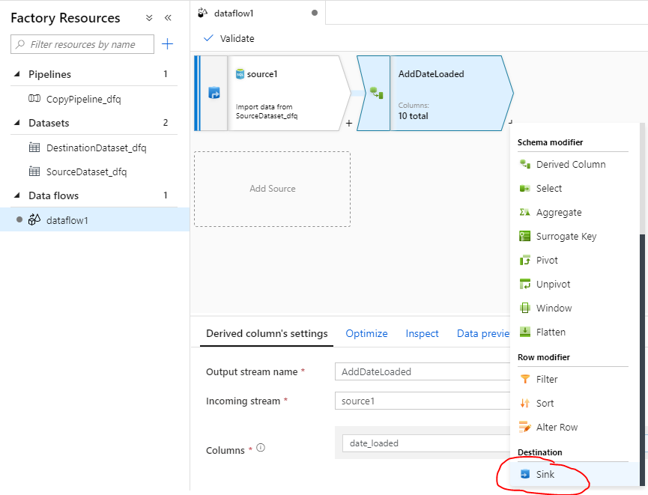

Click the ‘New’ button to add a new Sink:

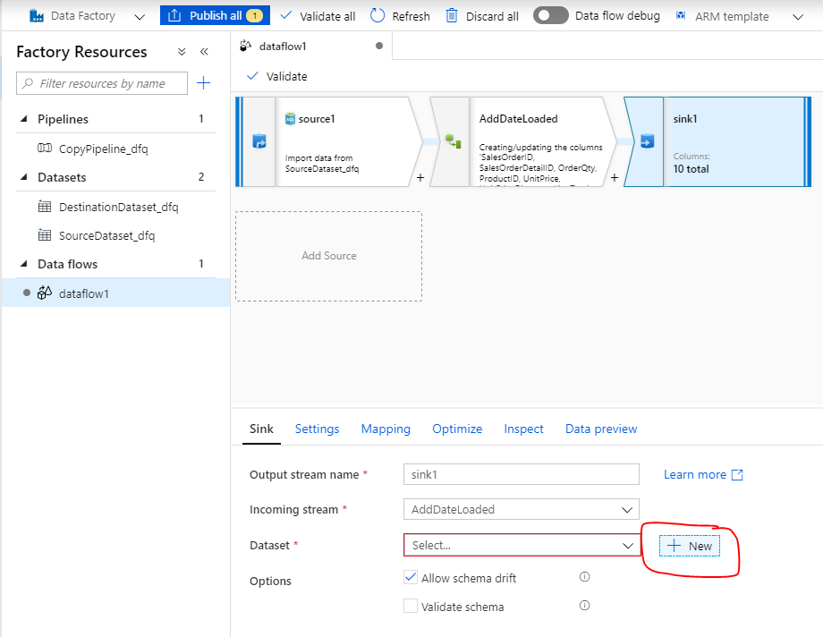

Set sink properties:

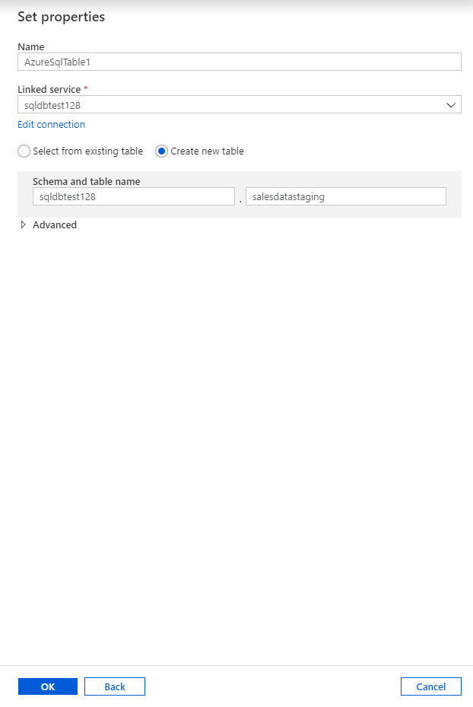

Configure setting so that the table is truncated if it already exists:

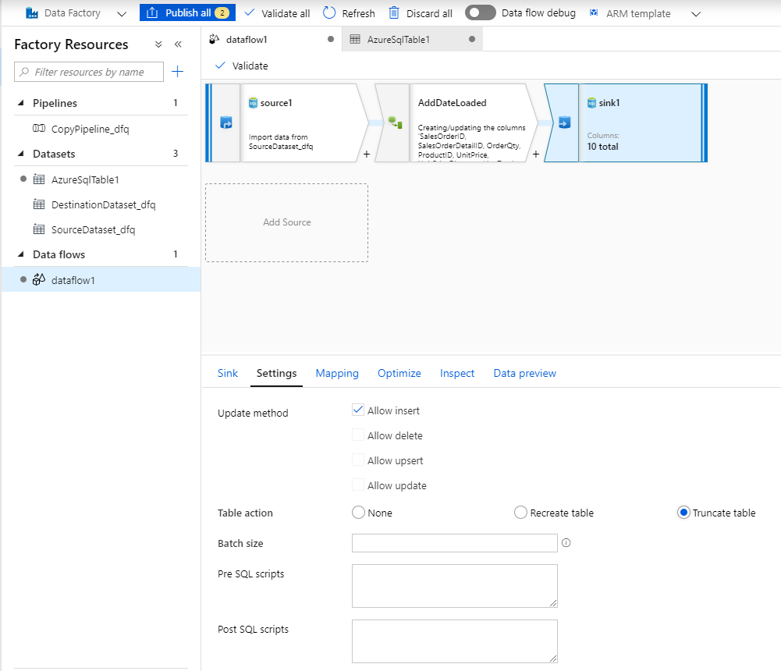

Next publish the dataflow:

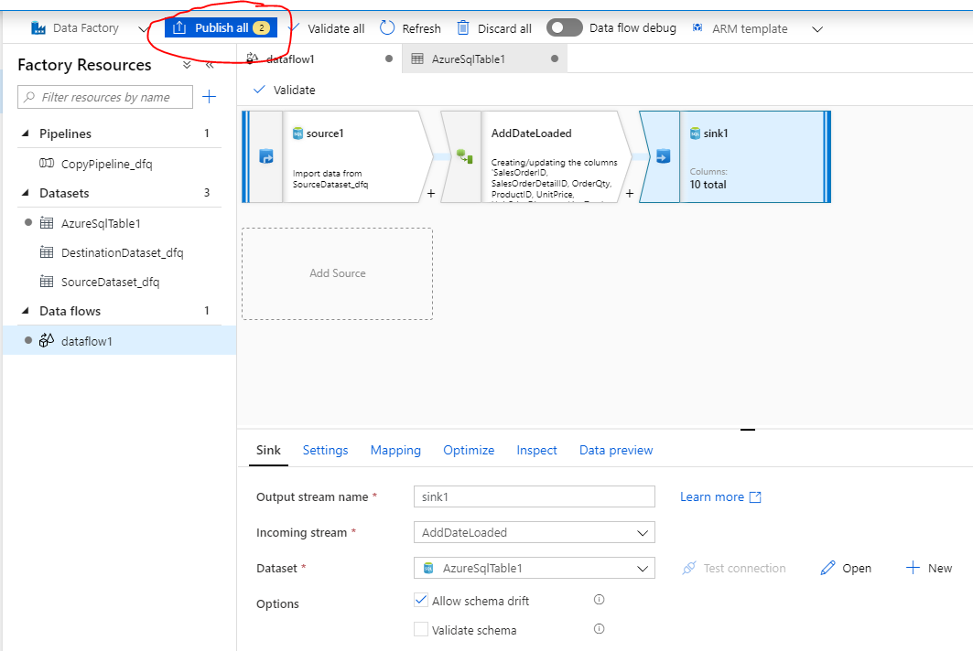

Publish All:

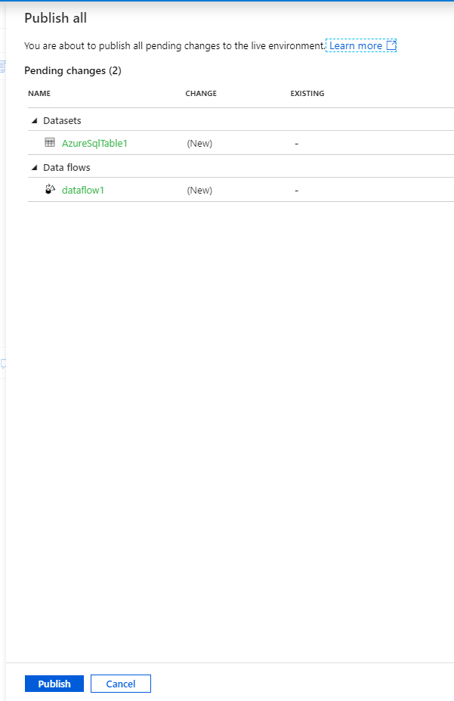

Now that it’s published, it can be added to a pipeline and then it can be run.